User 1: Fresher

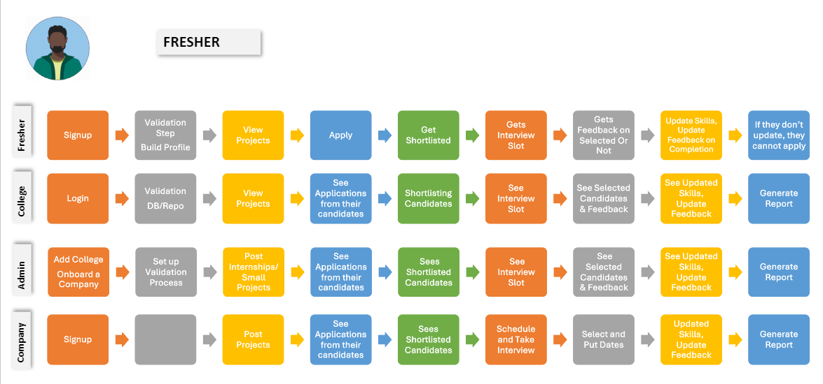

**Features Required**

1. **Sign up**
   1. Need to implement Sign up

1. **Build profile**

Need to add additional fields in profile page.

* 1. Add certifications
  2. Category of interests
  3. Add skills
  4. View points
  5. View level
  6. Download Profile
  7. View endorsements

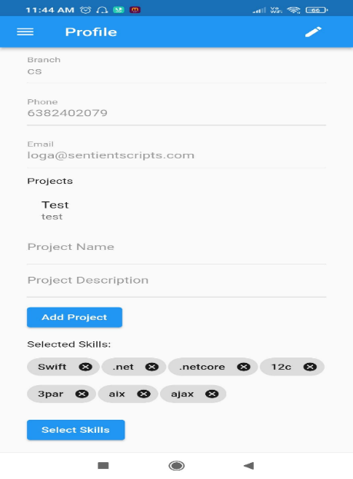

1. **View Main Feed** 
   1. Jobs
   2. Projects
   3. Quizzes
   4. News Updates

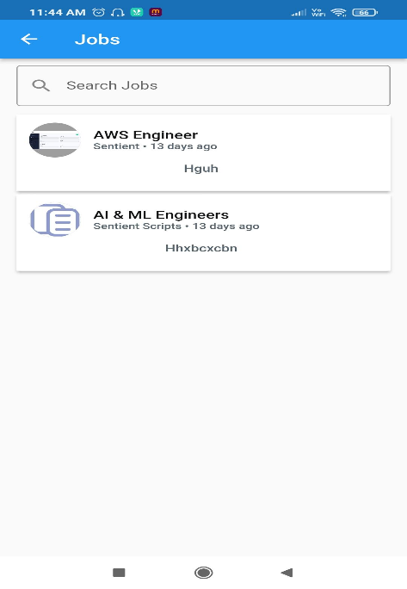

1. **Apply**
   1. Freshers can apply for projects/jobs
   2. View Applied projects/jobs
   3. Add toggle button to filter between jobs and projects

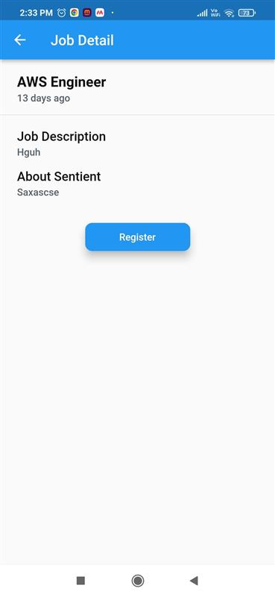 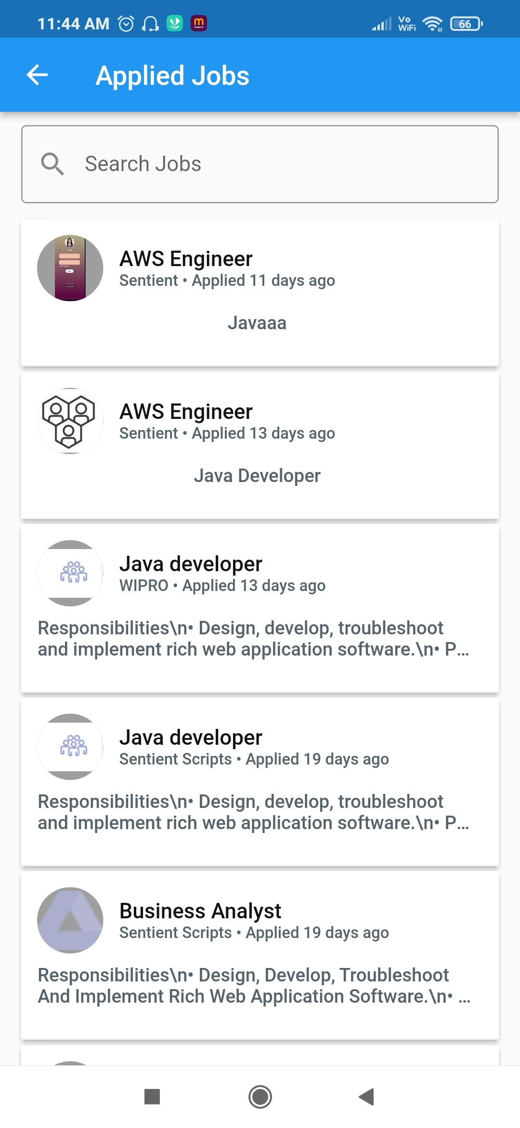

1. **Get Shortlisted**
   1. Should be able to view status of application under the applied job
   2. View attempted quizzes
2. **Gets Interview Slots**
   1. Should view interview slots selected by the interviewer also under the applied job
   2. Should also receive a mail with details of the interview
3. **Gets Feedback on Selection**
   1. Status to appear under the applied job
   2. A confirmation mail to also be sent to the fresher
   3. Tickets could be raised for issues by the candidates
4. **Update Skills**
   1. Once internship completed update skills in the profile page
   2. Skills update necessary to apply for jobs
   3. Seek feedback from the company